URL | Screenshot for 360schooltrip
http://www.thecollegetourist.com/when-youre-feeling-homesick/ - comment-49517 | 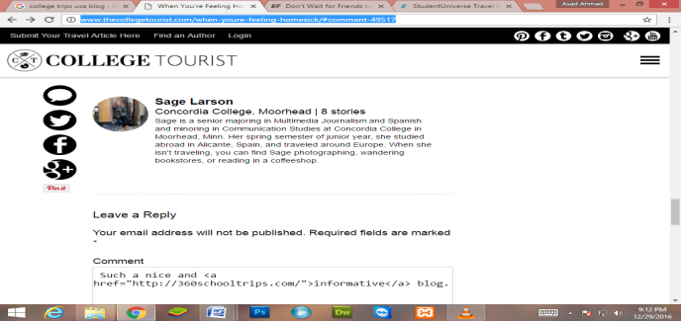
http://www.studentuniverse.com/blog/adventure/places-adventure-seekers - comment-22975 | 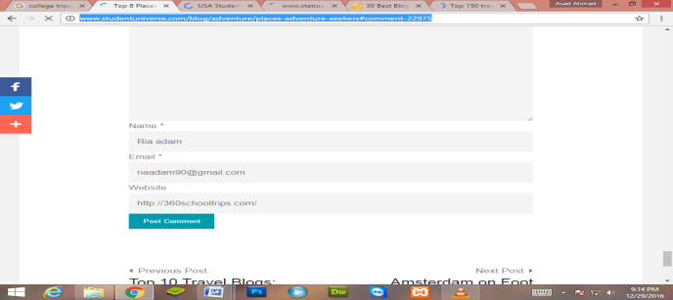
http://www.collegescholarships.org/blog/2010/10/06/top-150-travel-blogs-for-students/ - comment-396779 | 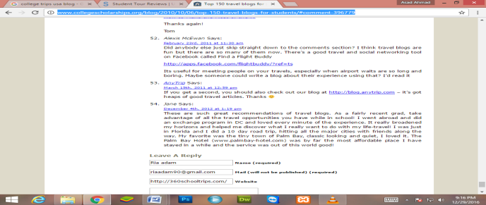
http://blog.internationalstudent.com/2016/08/tips-traveling-cheap-u-s/ - comment-1122418 | 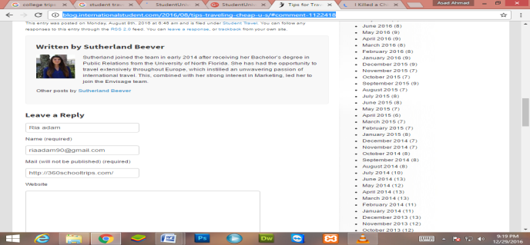
http://www.letsgo.com/blog/2016/09/30/i-killed-a-chicken-with-my-own-two-hands-pt-2/ - comment-2290
https://plus.google.com/+studentuniverse | 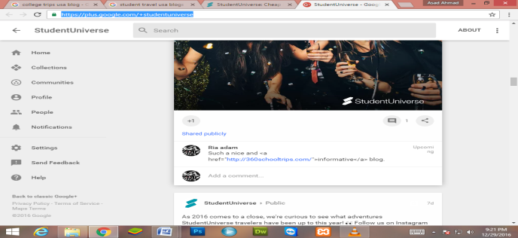
https://www.gooverseas.com/blog/96-student-travel-tips | 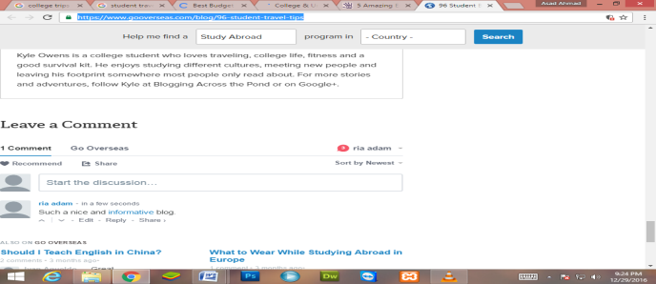
http://www.10best.com/awards/new-media-awards/best-budget-travel-blogger/ | 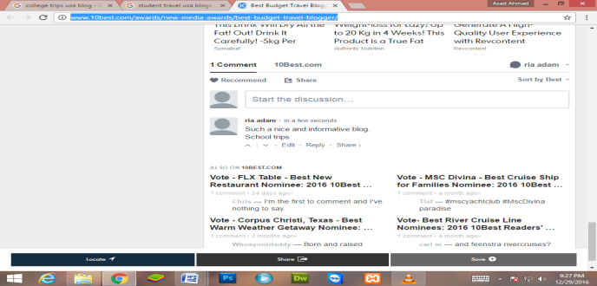
http://www.usastudenttravel.com/blog/2012/11/video-2013-universals-grad-bash/ - disqus_thread
http://blog.vitalchek.com/birth-certificates/school-enrollment/summer-travel-planning-for-college-students/ - comment-14491 | 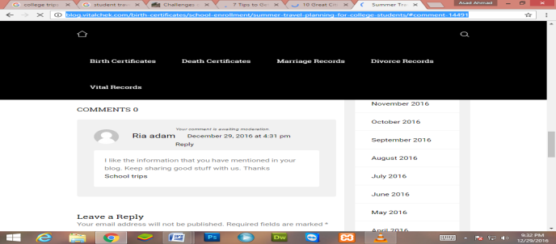
http://twenty-somethingtravel.com/2014/08/challenges-traveling-college-student/ - comment-2738674 | 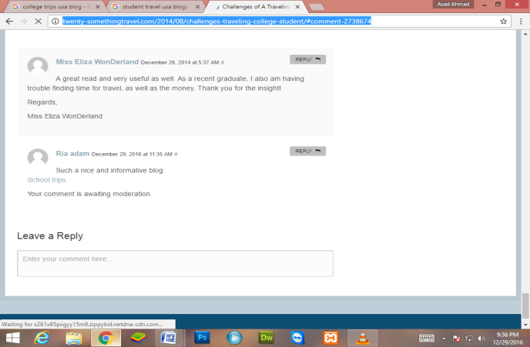
http://www.nationsclassroomtours.com/blog/easy-day-trips-to-add-to-a-d.c.-tour?success=true | 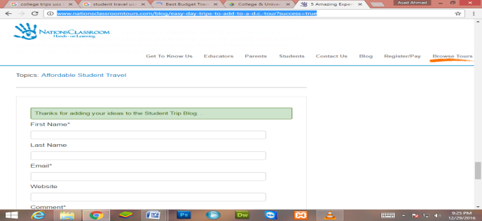
https://www.statravel.co.uk/travel-blog/2014/05/why-everyone-should-go-travelling-alone/ - comment-211850 | 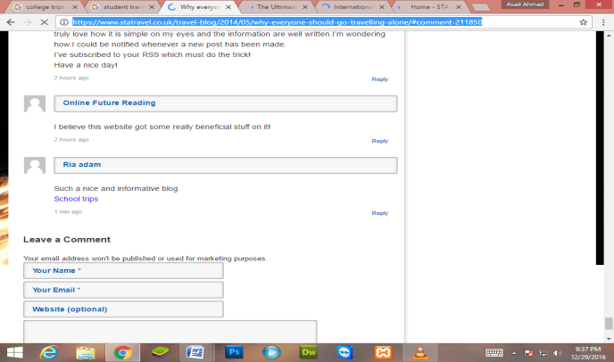
http://www.internationalstudentinsurance.com/blog/2016/12/two-insurance-plans-a-good-or-bad-idea.html - comment-332698 | 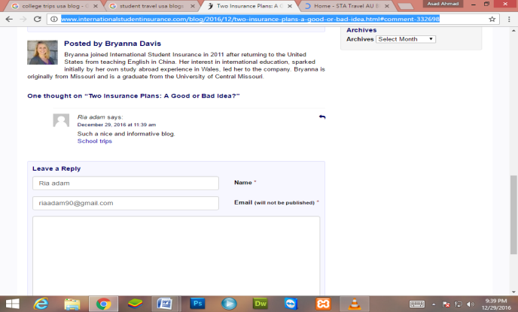
http://www.talk.edu/learn-english/student-travel-activities/10-best-student-travel-blogs-budding-traveler/ - comment-99417 | 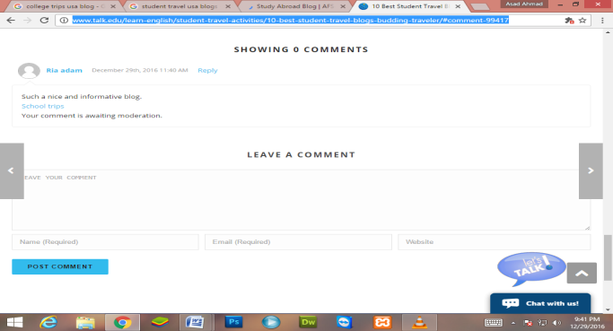
https://www.afsusa.org/study-abroad/blog/article/?article_id=9711

